# Manual Plastic Waste Flow Capturing Location Model

This is a manual of the Plastic Waste Flow Capturing Location Model. The input consists of environmental data of the surroundings, the output is a set of optimal locations given the available budget for catching systems for the chosen area.

To run the model, it is necessary to prepare the input data of the study area. This is done in part 1, where open source data is gathered in QGIS and pre-processed using some scripts and a bit of manual editing. In part 2, we move to a python environment. Here we set a few last input parameters such as properties of the catching systems and budget of the case study, and then we run the optimization model to find the best locations. In part 3, we go back to the QGIS project file and show the optimal locations on the map. You can use the tick boxes in the steps of part 1a and 1b to keep track of where you are. In the navigation tab of Microsoft Word you can see the overview.

## Useful parts of the manual for other Noria QGIS projects

There are several steps in this manual that are more widely applicable to other Noria projects in which QGIS is used. To save time to find these in the manual, here is an overview of where to find them:

* Creating QGIS waterpolygons of a new area: Part 1a – step 1.
* Creating QGIS waterways centerlines of a new area: Part 1a – step 2.
* Finding the locations of houseboats in a new area: Part 1a – step 5.
* Finding different types of sources in a QGIS point layer for a new area: Part 1a – step 6.
* Finding the location of sharp corners of a waterpolygons layer: Part 1b – step 6.

The best way to navigate to these locations is to read this document in Microsoft Word and use the navigation tab.

## Part 1: Setting up the QGIS project file with all necessary data

We will first set up the QGIS project with all necessary layers of GIS data. In part 1a, we will download layers from Open Street Map (OSM). In part 1b we will manually add some extra data using expert knowledge of the study area.  
Note: the model and manual were developed using QGIS version 3.32.2-Lima. There might be some differences when other QGIS versions are used.

1. Make a copy of the folder “Plastic Waste Flow Capturing Location Model” and rename the folder to: “name_city – Plastic Waste Flow Capturing Location Model”, where *name_city* is equal to the name of the study area that will be considered. Within the folder, also replace “name_city” in the name of the QGIS project of the file “name_city_PW-FCLM.qgz”. Open the QGIS project.

### Part 1a: OSM layers

**For each layer, export to CRS Amersfoort when exporting to a geojson file after downloading the OSM data. We will show this for the first file, but this should be done for each OSM export.**

#### 1. Waterpolygons

Note: The waterpolygon layers that were used in the thesis were made in previous Noria projects manually (likely by Konstantinos). An explanation of a way to obtain a waterpolygon layer is shown here, but it might be possible to obtain the waterpolygons using a different and more effective method. If you have a waterpolygon layer for the study area that is already made, then you can import it to the QGIS project via **Layer 🡪 Add layer 🡪 Add vector layer**, and skip to step 1.h to save it with the correct name.

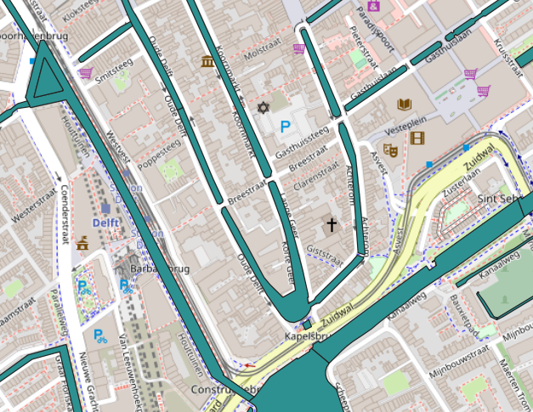  
Source: OSM

* 1. Open the **QuickOSM** plugin, go to **Query** and insert the following query:  
       
     [out:xml] [timeout:25];  
     {{geocodeArea:Delft}} -> .area_0;  
     (  
      way["natural"="water"](area.area_0);  
      relation["natural"="water"](area.area_0);  
     );  
     (._;>;);  
     out body;  
       
     Select ONLY the **Multipolygons** and click **Run query.** (Look at screenshot on next slide to see the steps in the QGIS window).  
     *This example is for Delft, change "*geocodeArea*" value to pick a different city.  
     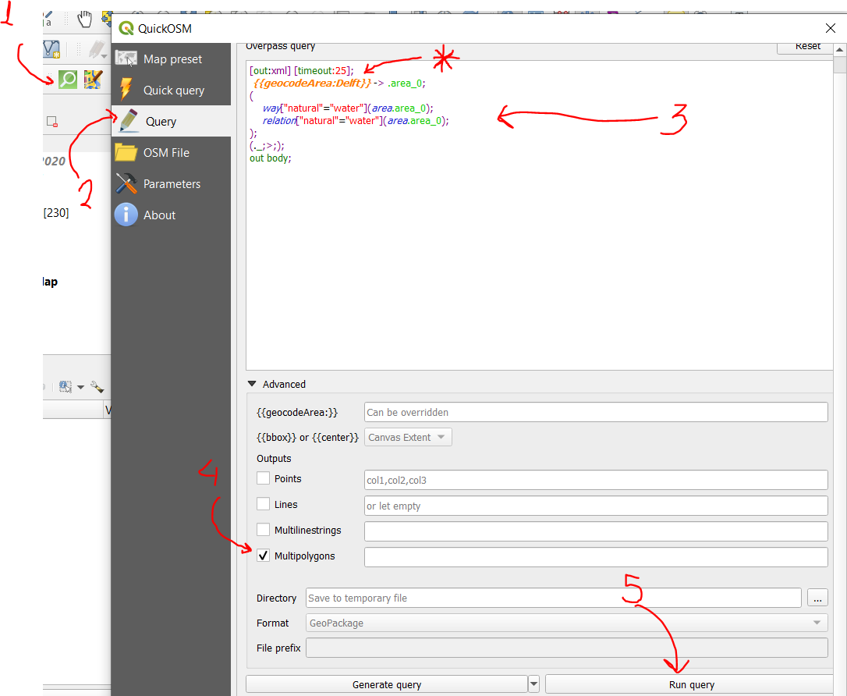
  2. The layer will contain polygons of the water for all small ponds and ditches in the area, therefore it is necessary to delete the features of waterpolygons that you do not want to include in the analysis of the area. Select the waterpolygons that are not part of the study area and delete them.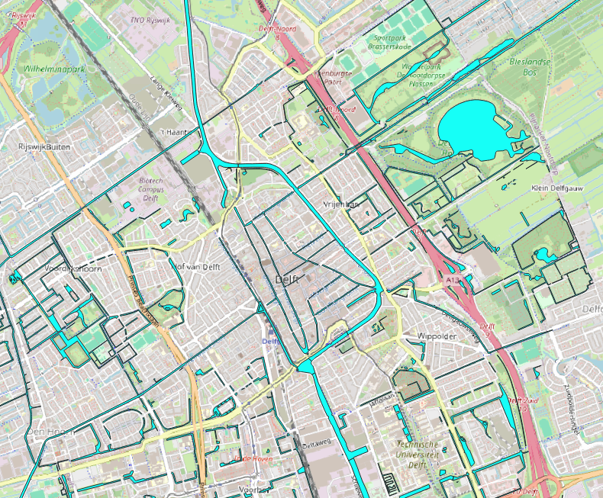
  3. After deleting unnecessary waterpolygons, it is probably also necessary to cut off parts of some of the remaining polygons by deleting the vertices. Use the *vertex tool* in QGIS and select the vertices by selecting a square to delete them.

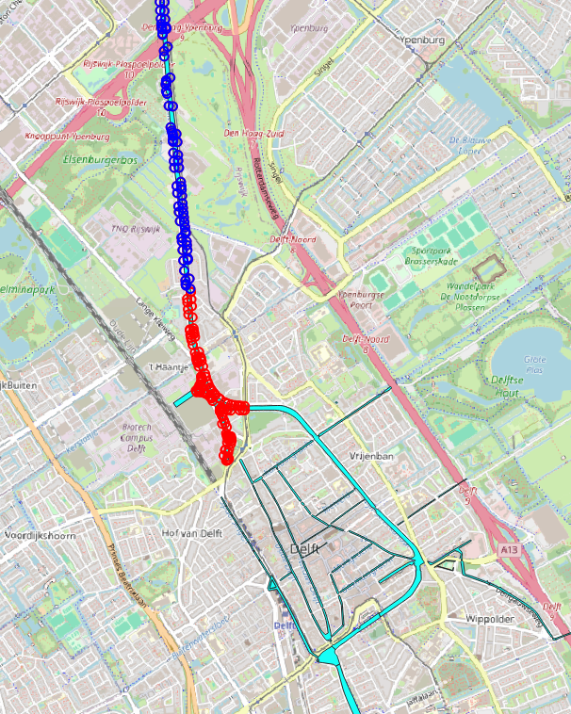

* 1. Now we make a polygon layer of the bridges because the waterpolygons are cut out in the locations of the bridges. Open the **QuickOSM** plugin again and go to **Query.** Insert the following query:  
       
     [out:xml] [timeout:25];  
     {{geocodeArea:Delft}} -> .area_0;  
     (  
      way["man_made"="bridge"](area.area_0);  
     );  
     (._;>;);  
     out body;

Select ONLY the **Lines.**

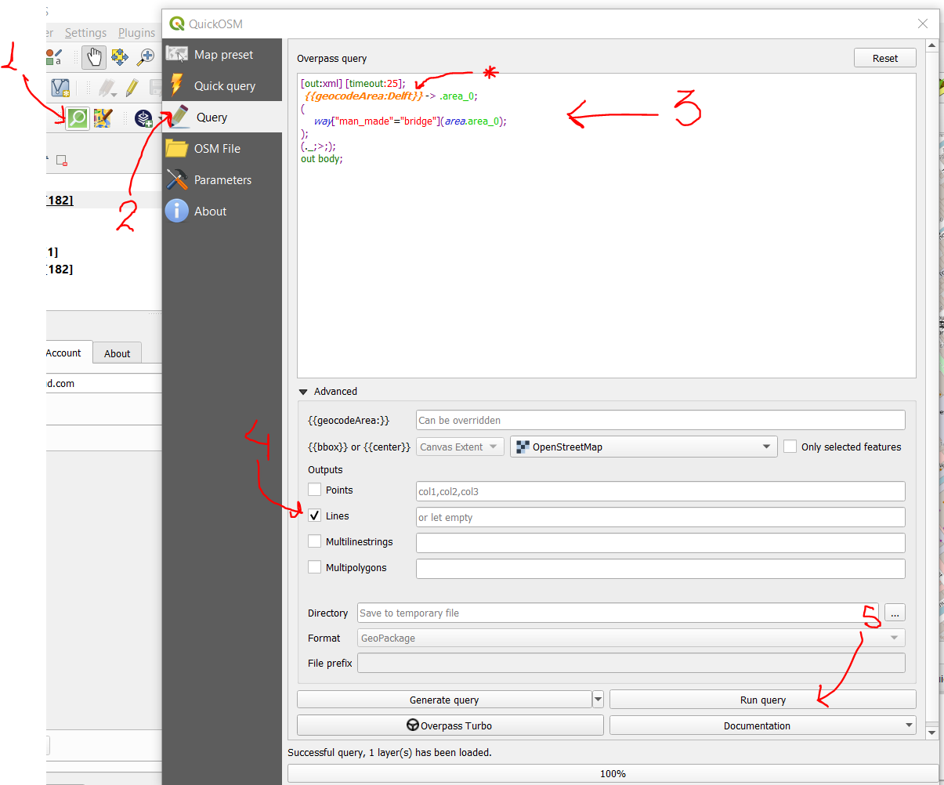

* 1. Run the algorithm **Vector 🡪 Geometry Tools 🡪 Lines to polygons** with the OsmQuery line layer of bridges as input. Then take the difference between the bridges polygon layer and the OSM query polygon layer of waterpolygons using the algorithm **Vector 🡪 Geoprocessing Tools 🡪 Difference** with the bridges “Polygons” layer as input and the waterpolygons “OsmQuery” polygon layer as overlay: 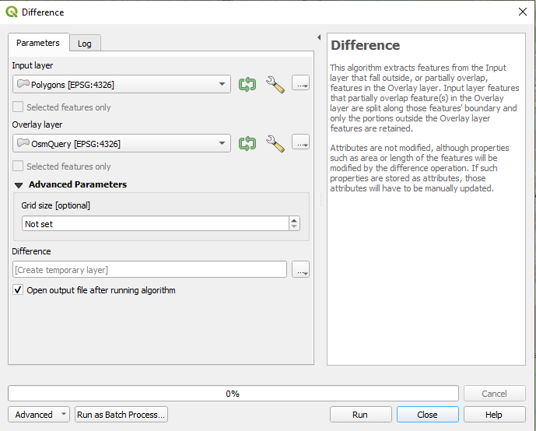
  2. The resulting “Difference” layer now contains all bridges that do not intersect with the waterpolygons: 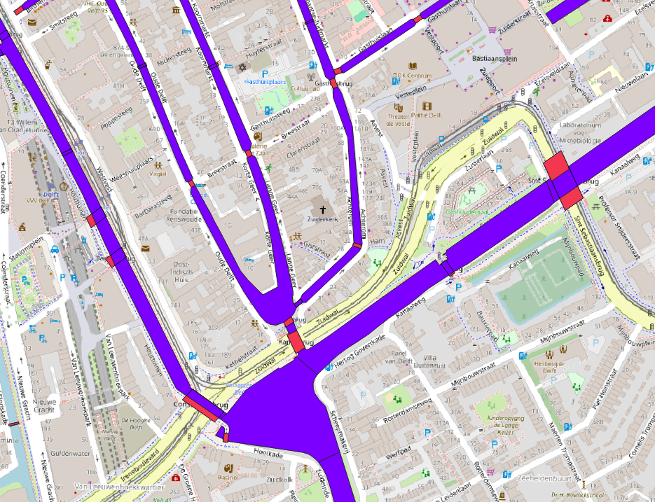



Delete the unnecessary parts in the “Difference” layer that are not bridges that should be part of the waterpolygons. These are the bridges that are wider than the water (circled in green). Also delete bridges that are outside the extent of the study area.

* 1. Then we join the bridges polygons layer with the waterpolygons layer using **Vector 🡪 Geoprocessing Tools 🡪 Union** with the “Polygons” layer as input and the “OsmQuery” waterpolygons layer as overlay. Then if there are still gaps in the waterways where you do not want them, then manually add them by drawing extra polygons in the “Union” layer. Draw them by hand and make sure to click the vertices in a clockwise way when drawing a new polygon. Turn on the snapping tool (the symbol is a magnet) while drawing the new polygons such that the vertices are exactly in the same position as the attached waterpolygons. It is not necessary to add any values for the attributes when drawing a new polygon.
  2. When you are happy about the final extent of your waterpolygons layer that includes all parts of the waterways that were missing in the OSM Query, the “Union” layer needs to be exported to a permanent file with the correct CRS as follows: 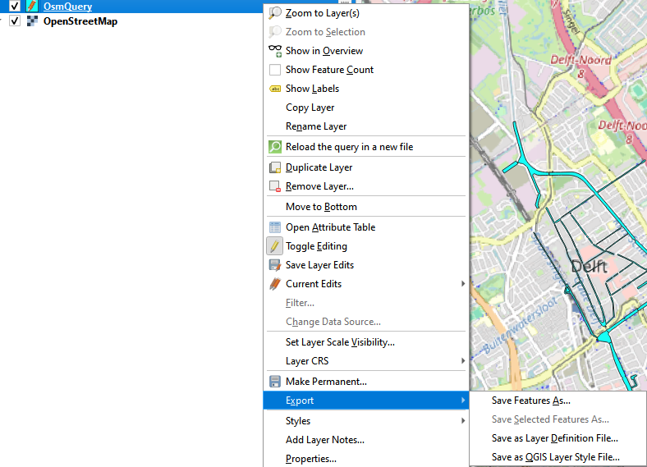



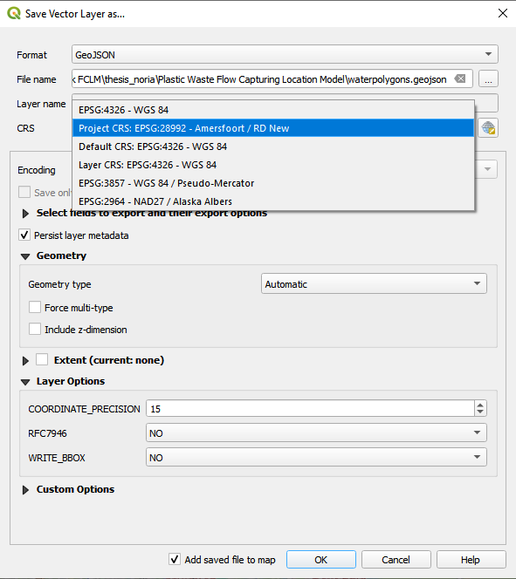

Select the correct folder of this project/study area



Ensure that the final layer is called “waterpolygons.geojson” and that it is stored in the same folder as the QGIS project!  
If an extra window pops up about the coordinate transformation, just click OK.

#### 2. Waterways:

1. Open the **QuickOSM** plugin
2. Go to **Quick query** and enter key:waterway. In: name_city (Delft).
3. Select only the lines and click **Run query**

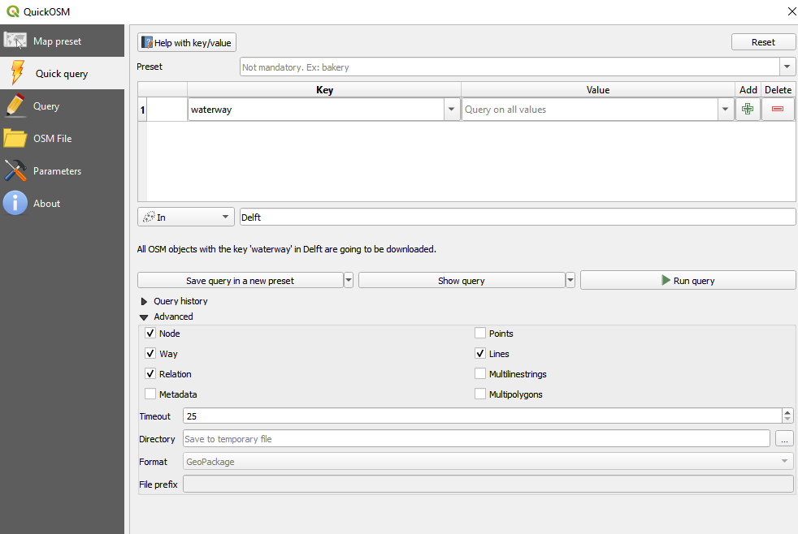



1. The waterways are also outside of the range of the waterpolygons. So we need to clip the waterways: 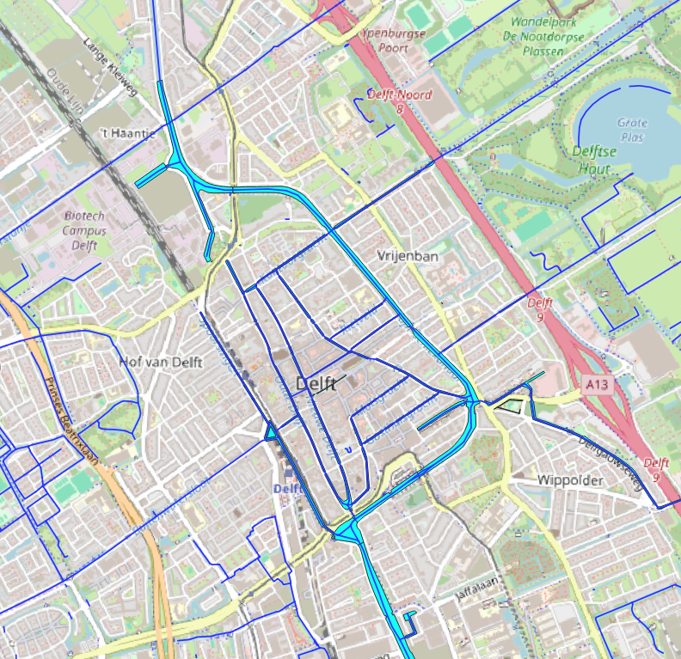
2. Click **Vector 🡪 Geoprocessing Tools 🡪 Clip** and s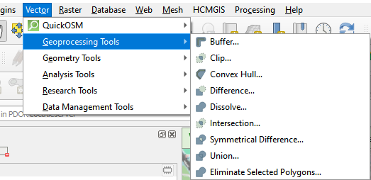
3. Change the input layer to the waterways layer and the overlay later to the waterpolygons and then click Run.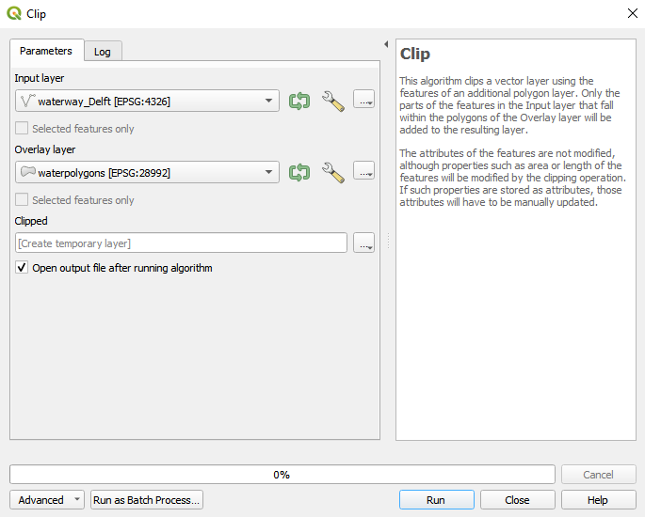
4. Export the waterways layer with the correct CRS as shown in step 1.h. for the waterpolygons. Ensure that the final layer is called “waterways_detailed.geojson” and that it is stored in the same folder as the QGIS project!
5. Now we need to simplify the waterways layer because the level of details is too high for the number of nodes in the optimization model in Part 2. In this step we want to remove the nodes such that nodes only remain in locations that are intersections or significant changes in the direction of the waterway.  
   Export the same layer again, with the correct CRS as shown in step 1.h. for the waterpolygons. Ensure that the final layer is called “waterways_simplified.geojson” and that it is stored in the same folder as the QGIS project! We will edit this layer by deleting all unnecessary vertices and moving the remaining vertices on the intersections.

Tips to do this:

* Set the layer to editing mode and go to the vertex tool (the symbol for the vertex tool has a hammer in it). Turn on the snapping tool (looks like a magnet) and activate “enable snapping on intersections”.
* Go over the entire study area in a structured way (north to south, east to west or similar) and select a segment by making a square on top of the line layer such that the underlying vertices become visible in dark blue circles. Delete the unnecessary vertices.
* Move the remaining vertices on the intersections and changes in direction of the waterway to make sure they represent the water as much as possible. The best way to move all vertices that are snapped together at the intersection is to select the intersection with a square and then move all vertices at once. If you select the vertex on the intersection by clicking on it, then you need to move all vertices that come together in the intersection separately which can lead to errors and takes more time.  
  It is fine if the simplified waterlines do not exactly fit in the waterpolygons, as long as the direction of the waterlines is approximately correct. (See example screenshot on next page).
* Sometimes the waterway is split up into two “parallel” parts at large bridges with two openings. If you delete the vertices in the middle of these two parallel parts, this could result into two overlapping edges, which we don’t want. If this is the case, is important to delete the whole segment instead of just the vertices. This does not happen often, but is a rare and specific case.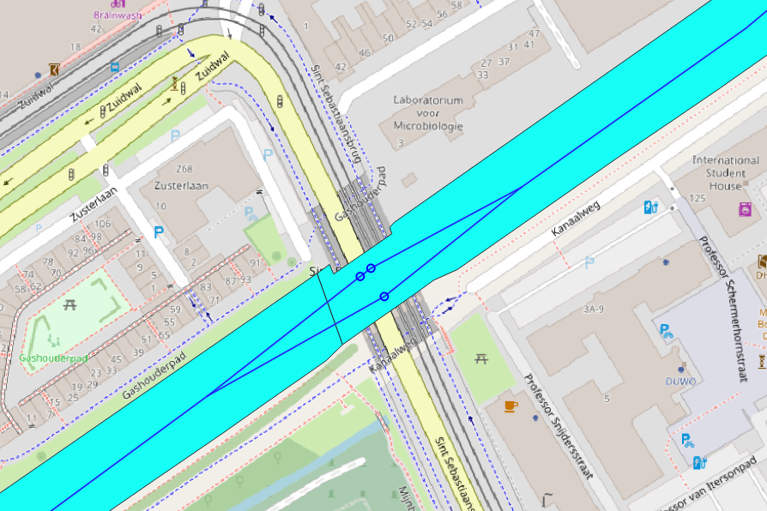
* If a line is missing somewhere, you can just add a new line segment. It is not necessary to give any values to the columns in the attribute table.

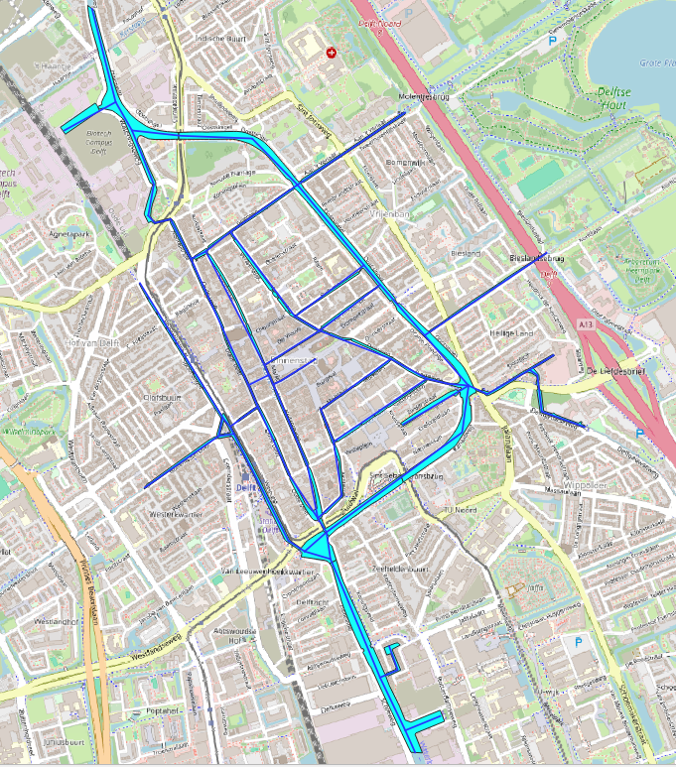

1. Explode the waterlines when you are done editing using **Processing Toolbox 🡪 Vector Geometry 🡪 Explode lines** with the “**Simplified”** layer as input layer and set the advanced settings (click the wrench icon in older QGIS versions) to “Skip (Ignore) Features with Invalid Geometries) such that non-valid geometries from the manual editing are automatically removed.
2. Export the exploded and simplified waterways layer with the correct CRS as shown in step 1.h. for the waterpolygons. Ensure that the final layer is called “waterways_simplified.geojson” and that it is stored in the same folder as the QGIS project!

#### 3. Layer of corner nodes (for deciding number of vertices that are necessary)

1. Run the algorithm **Vector 🡪 Geometry Tools 🡪 Extract Vertices** with the waterways_simplified layer as input.
2. Run the **Processing Toolbox 🡪 Vector general 🡪 Delete duplicate geometries** algorithm with the vertices from step 3a. as input. This is because some vertices will be extracted in double.
3. Export the final vertices layer (the temporary layer is called “Cleaned”) with the correct CRS as shown in step 1.h. for the waterpolygons. Ensure that the final layer is called “corner_nodes.geojson” and that it is stored in the same folder as the QGIS project!

#### 4. Layer of intersection nodes (no catching systems are allowed here)

1. Make a copy of the “corner_nodes” layer by clicking the layer and exporting it again. Ensure that the new layer is called “intersection_nodes.geojson” and that it is stored in the same folder as the QGIS project!
2. Set the layer to editing mode and remove the vertices that are not intersections but dead ends. In this case, do not use the vertex tool to delete the vertices but select the features and delete them. If you delete only the vertices, the features will remain in the layer with a “null-geometry”, which is why we need to delete the entire feature. Save the layer after editing.

#### 5. Houseboats

1. Open the **QuickOSM** plugin
2. Go to **Quick query** and enter key: building, value: houseboat). In: name_city (Delft).
3. Click **Run query**
4. Export the houseboats layer with the correct CRS as shown in step 1.h. for the waterpolygons. Ensure that the final layer is called “houseboats.geojson” and that it is stored in the same folder as the QGIS project!

#### 6. Sources

1. Open the **QuickOSM** plugin
2. Go to **Quick query** and enter the keys and values as shown below. Make sure that the dropdown menu on the left is set to “Or” and not “And”. In: name_city (Delft).
3. Select only the points and click **Run query**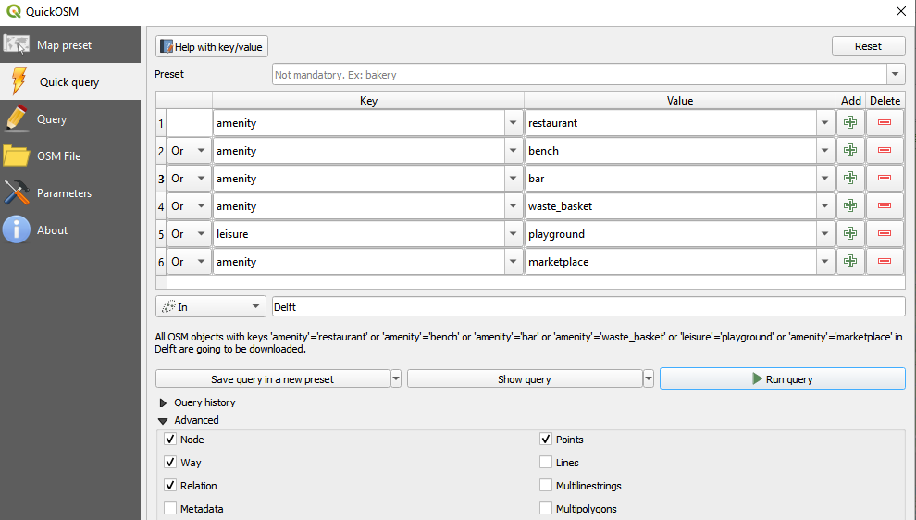
4. Export the sources layer with the correct CRS as shown in step 1.h. for the waterpolygons. Ensure that the final layer is called “sources.geojson” and that it is stored in the same folder as the QGIS project!

### Part 1b: Manual QGIS editing and pyqgis scripts

#### 1. Max boat width polygon (for catching probabilities)

* 1. Buffer the waterways polygon using: **Vector🡪Geoprocessing Tools 🡪 Buffer** and run the algorithm with a distance of 30 meters. This is necessary because waterlines might be outside because of the simplificiation of the waterways we did previously.

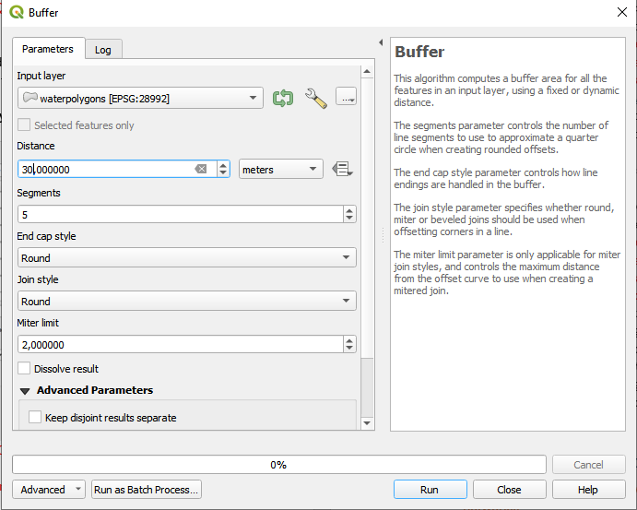

* 1. Take the union of the **“Buffered”** layer using **Vector🡪Geoprocessing Tools 🡪 Union**. Then cut the **“Union”** layer into parts using the Split features tool. Note: if the split features tool does not seem to work, this might be because you are trying to split up a feature that is still connected via a different route. For example, you need to split the city center from the Schie from all sides at once as shown in the image below.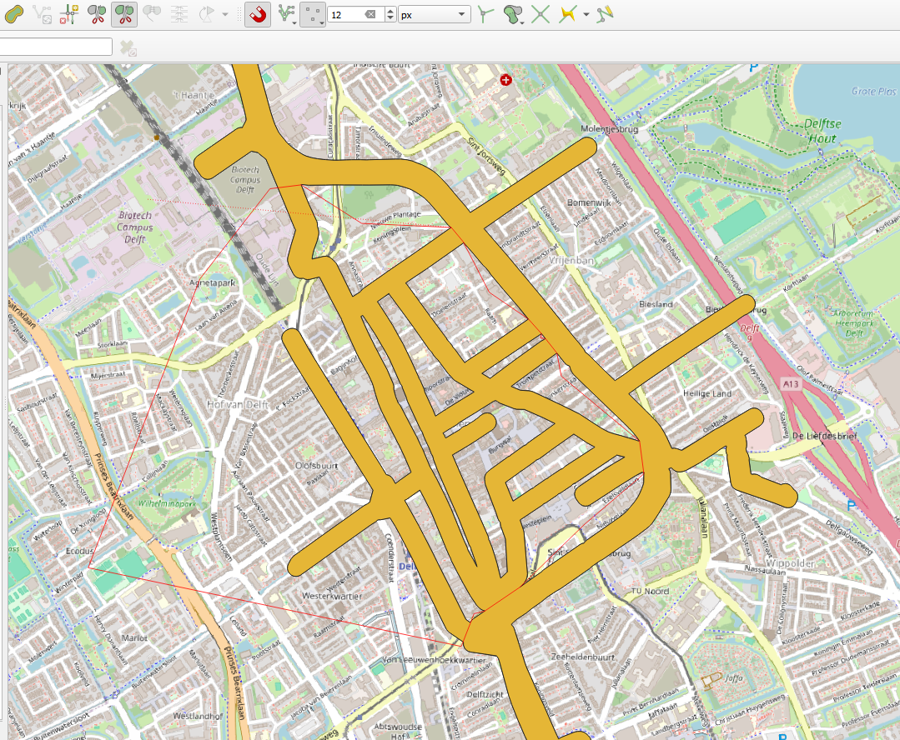

Split features tool



* 1. Make the layer editable, open the attribute table. Add a new column called “max_boat_width” of type “Decimal number (real)”.
  2. Go back to the map, select the entire layer and click **Edit 🡪 Edit Attributes 🡪 Modify Attributes of Selected Features**. Change the max_boat_width of all features to the value of the max_boat_width that is true for most locations.
  3. Deselect the layer and start selecting specific parts of the layer where the max_boat_width is different from the value we just used for the whole layer. Edit the attributes for these selected features.
  4. Export the max boat widths layer with the correct CRS as shown in step 1.h. for the waterpolygons. Ensure that the final layer is called “max_boat_width.geojson” and that it is stored in the same folder as the QGIS project!

#### 2. Shore properties (wall, vegetation or houseboats)

1. We will make a vector layer of the outlines of the waterpolygons. First we need to dissolve the waterpolygons using the algorithm **Vector 🡪 Geoprocessing Tools 🡪 Dissolve** with the waterpolygons layer as input layer.
2. Then we get the outlines of the dissolved waterpolygons layer by using the algorithm **Vector 🡪 Geometry Tools 🡪 Polygons to Lines** with the "**Dissolved**" layer from the previous step as the input layer.
3. We explode the resulting layer using the algorithm **Processing Toolbox 🡪 Vector geometry 🡪 Explode lines** with the “**Lines”** layer from the previous step as the input layer.
4. Export the final layer with the correct CRS as shown in step 1.h. for the waterpolygons. Ensure that the final layer is called “shore_types.geojson” and that it is stored in the same folder as the QGIS project!
5. Open the attribute table of the lines layer. Set the layer to editing mode, there should already be a column called “type” of type “String” (if the column somehow does not exist yet, add it).
6. Go back to the map and select the entire layer and and click **Edit 🡪 Edit Attributes 🡪 Modify Attributes of Selected Features**. Change the type of all features to “wall”.
7. Deselect the layer and start selecting specific parts of the layer where there are houseboats (which we can see from the houseboats layer) and set the type to “houseboat”
8. Using expert knowledge from the study area (or your own experience), select the specific parts of the shore where there is shore vegetation and set the type to “vegetation”.
9. Save the layer after editing.

#### 3. Water vegetation

1. Copy the water polygons layer by exporting it. Ensure that the copied layer is called “water_vegetation.geojson” and that it is stored in the same folder as the QGIS project!
2. Delete the polygons that have no water vegetation. If necessary, it is also possible to edit the shapes of the single parts in the polygon layer. Save it afterwards.

#### 4. Impact factor sensitive areas

1. If there is an area where it is particularly important that plastic is caught, it is possible to set an impact factor for this area. Create a new polygon layer and make a polygon by clicking to create new vertices, such that the shape of the polygon is the outline of the sensitive area.
2. Export the sources layer with the correct CRS as shown in step 1.h. for the waterpolygons. Ensure that the final layer is called “sensitive_area.geojson” and that it is stored in the same folder as the QGIS project!

#### 5. Get wind data from KNMI [www.knmi.nl/nederland-nu/klimatologie/daggegevens](http://www.knmi.nl/nederland-nu/klimatologie/daggegevens)

1. Find the weather station that is closest to the study area. Download the data from that weather station, unzip the folder and take the etmgeg file from this zip folder and save it to the folder: “pulp_scripts”.
2. Rename the file to “wind_data.txt”.

#### 6. Sharp corners

1. Open the script “pyqgis_scripts/sharp_corners.py” in the python window of QGIS and click run.
2. A temporary layer is created. Load the style file “sharp_corners_style” from the “style_files” folder for this layer.

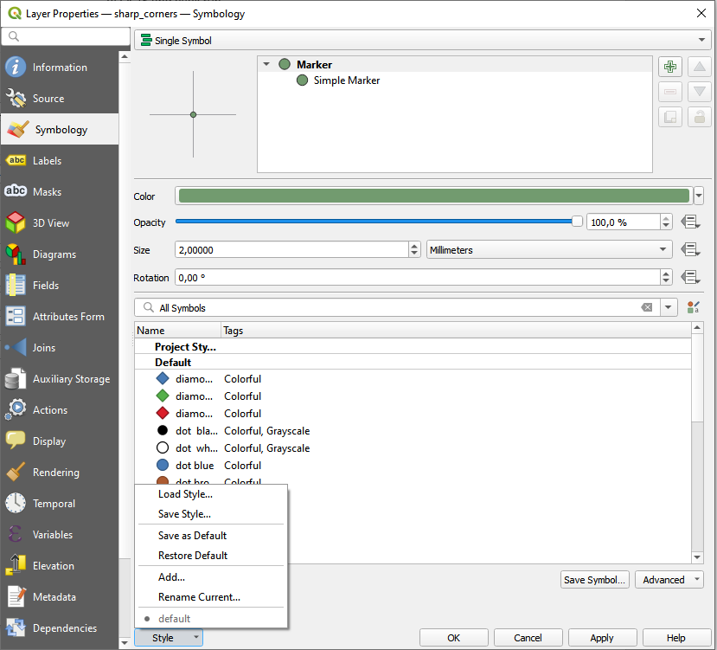



1. The large green circles are corners that the script considered as sharp corners but there are still a few errors in the script. Therefore, manually check if all sharp corners are correct and change the attribute value “sharp” of corners that are considered sharp but are not from 1 to 0.

The best way to do this is to manually go over the study area and select all sharp corners that seem wrongly classified as sharp (=1), then click **Edit 🡪 Edit Attributes 🡪 Modify Attributes of Selected Features** and change the attribute value “sharp” to 0.

Especially look at the sharp corners at the edge of the waterpolygons. If there is a sharp corner at a dead end, this should be a sharp corner (sharp = 1). However if there is a sharp corner at the edge of the waterpolygon where the waterway continues but is no longer considered in the study area, then this should not be a sharp corner (sharp = 0). Here is an example: 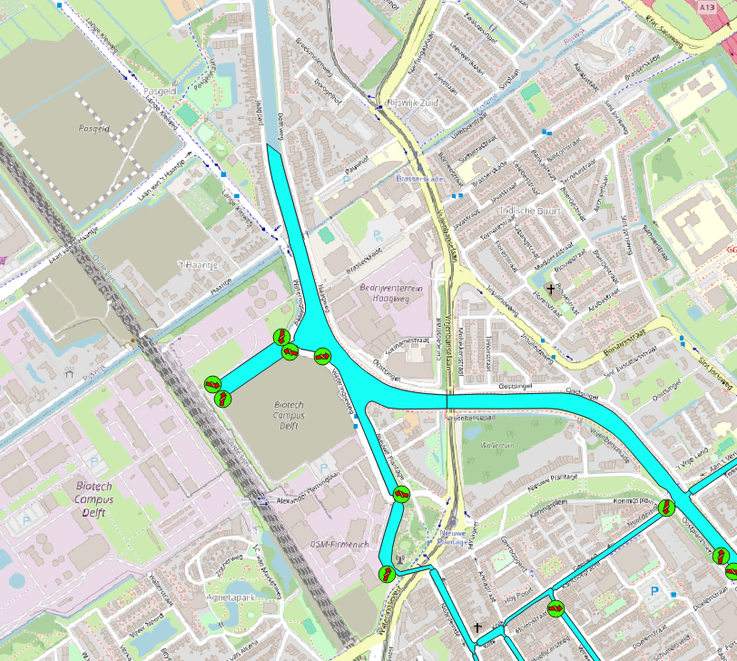

Not sharp corners, this is the edge of the study area.  
Plastics will not get stuck in the sharp corner formed by the waterpolygon because they can actually continue outside of the study area.

These are actually sharp corners at the dead end where plastics could get stuck.



1. Export the sources layer with the correct CRS as shown in step 1.h. for the waterpolygons. Ensure that the final layer is called “sharp_corners.geojson” and that it is stored in the same folder as the QGIS project!

#### 7. Run files to simplify network

1. Open the script “pyqgis_scripts/create_final_network.py” in the python window of QGIS and click run.
2. Note: the number of nodes is decided by the model and is chosen such that the Gurobi solver can be used without a license. It is possible to change the number of nodes to add more detail, note that it might be necessary to change the solver that is used (to the open source solver CBC instead of Gurobi, it is a lot slower unfortunately).

#### 8. Run files to create MDP input

1. Open the script “pyqgis_scripts/create_mdp_inputs.py” in the python window of QGIS and click run.  
   The assumptions that were made for the transition probabilities, initial probabilities and probabilities of getting stuck are explained in detail in my thesis. If you ever want to change these probabilities, this can be easily done using the “data_parameters.yaml” file.

## Part 2: Optimization in Python

We now leave the QGIS environment and open a Python IDE of your preference (e.g. spyder, pycharm, VScode).

### Creating a virtual environment with the correct packages

Create a virtual environment with following pip packages: numpy, scipy, matplotlib, geopandas, pulp, networkx and gurobipy. It is also possible to use the requirements.txt file from the folder. The versions of the packages should not be an issue but this might change in future versions.

### Setting the correct parameters for the model

Open the text file “MILP_parameters.yaml” from the folder “pulp_scripts”. Set the correct costs and accuracy for each type of catching system (the first element of the list is the price for active catching system and the second element of the list is the price of the passive catching system. The default values are set to costs = 1 for the active system and 0.2 for the passive system (the active system is 5 times more expensive than the passive system). The default accuracies are 98% accuracy for the active system and 85% accuracy for the passive system.  
Then set the correct total maximum budget that you want to use for the run of the model. Keep in mind that this maximum budget should be proportional to the number of catching systems that you want to be placed in the run of the model. If the total budget is 0.6 in this example, then it means no active catching system can be placed with the current costs and 3 passive systems can be placed.

The parameter “weight_costs” is a trade-off between catching extra plastics vs how much extra money it costs to catch them. If weight_costs = 0, then an extra catching system will always be placed if the budget allows it. Choose this value if you want the model to always place extra catching systems, even if the extra system only catches very little plastics compared to its costs.  
With the default value weight_costs = 0.001, it means that an extra catching system of cost 1 should catch at least 0.1% of the plastics in the entire area and an extra catching system of cost 0.2 should catch at least 0.05% of the plastics in the area.   
It is possible to choose weight_costs between 0 and 1, but it is advised to choose a value between 0.001 and 0.1 (0.1 would mean that a catching system of cost 1 should catch at least 10% of the plastics in the entire area). If the value of weight_costs is set too high, then it is possible that no catching systems will be placed at all.

### Test for different values of $α$ and choose one

It is necessary to choose a value for the impact factor $α$ to make a trade-off between catching as much plastics as possible and catching them as early as possible or in certain sensitive areas. If the main goal is just to catch as much as possible, then you can set the following values in the MILP_parameters.yaml file and skip the next explanation and move on to step 4.  
 tests_catching_early: []  
tests_sensitive_area: []  
impact_factor_catching_early: 0  
impact_factor_sensitive_areas: 0

Open the file “load_instance” from the folder “pulp_scripts” in your Python IDE. Run the entire python script to see three plots appear in which an example of the amount of flow caught in total and the amount of flow leftover in the sensitive area is shown. The first plot is an example of the effect of choosing the impact factor $α$ for catching early for different default values of $α$ that should theoretically be the range in which you want to choose $α$ for catching the plastics as early as possible. In the second and third plot, the effect of choosing different values for the impact factor is shown using the values from the “MILP_parameters.yaml” file. You can adjust the values shown in the second and third plot by running the file again after changing the lists tests_sensitive_area: […] and tests_catching_early: [] in the yaml file as follows:

1. First look at the first plot with the default values for alpha for catching early. Choose a few values of alpha within the range where the graph drops. 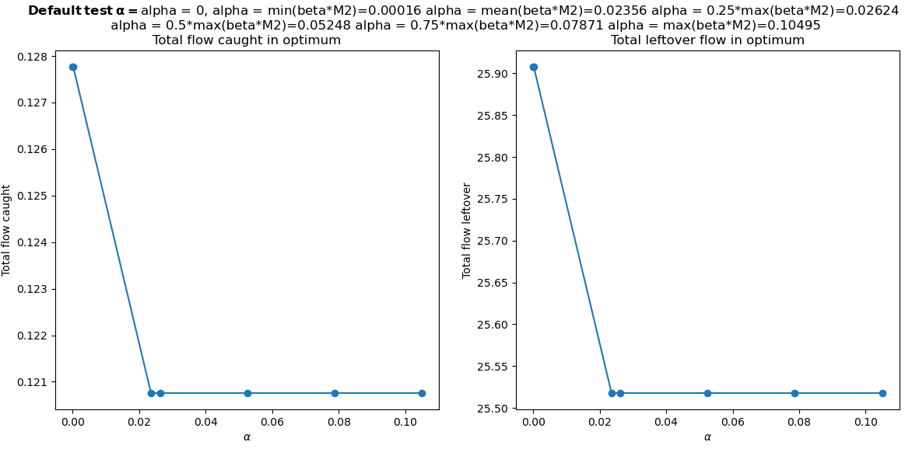

In this example we see that we catch approximately 0.7% less plastics in total (0.128-0.121) if we increase $α$ for catching early to $α=0.02$. This leads to a decrease of plastics in the total area of 0.40 (25.90-25.50). Since the total flow is equal to one, this means that the plastics visit 25.9 nodes on average if we don’t use $α$ for catching early and they visit 25.4 nodes on average when we increase $α.$ Since this is not a very large improvement while the total flow caught decreases, it is probably a wise decision to set $α=0$ for catching early. To check if there are any better options between 0 and 0.02 we change the list tests_catching_early: [0.005, 0.01, 0.015, 0.02] in the MILP_parameters.yaml file.

1. Then we look at the third plot where we see a few example values for setting $α$ to a higher value in the sensitive area. 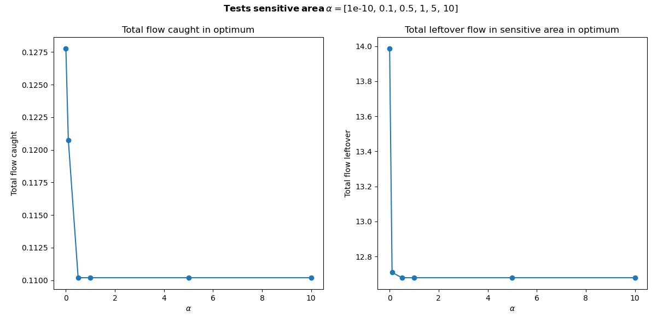

Here we see a smaller decrease on the left plot in the toal flow caught and a larger decrease on the right in the total leftover flow in the sensitive area for $α=0.1$ Therefore, we want to test some values of $α$ in the range around this value, so we change the list tests_sensitive_area: [0.025, 0.05, 0.075, 0.1, 0.125] in the MILP_parameters.yaml file.

Then we run load_instance again and look at the new version of the second and third plot. You can repeat this again if you want to check more different values. Finally change impact_factor_catching_early and impact_factor_sensitive_areas to the chosen values based on the second and third plot respectively. For this specific example it seems like the best choice is to set $α=0$ for both catching early and for the sensitive area, because the decrease in total flow caught is quite large.

So we can always turn off the trade-off with catching plastics in sensitive areas by setting $α_{i}=0 ∀i∈V$. There are several situations in which it is advised to set the impact factor to zero anyways:

* The model is very slow, it takes several hours before the first plot appears. This could be the case when the budget is large or there are a lot of nodes. Then it is not feasible to test the different values of $α$ by running the model several times so it is better to run it with $α=0.$
* The drop in the plots is too large or not visible at all.

In section 6.3.2 and 7.1.2 in the [thesis](https://repository.tudelft.nl/record/uuid:28744e34-9bbc-40dc-9039-d52ed2f771e5) we see an example where the total flow caught (left plot) decreases only a little bit while the total leftover flow decreases a lot. In that case we chose a higher value of $α$ for catching early: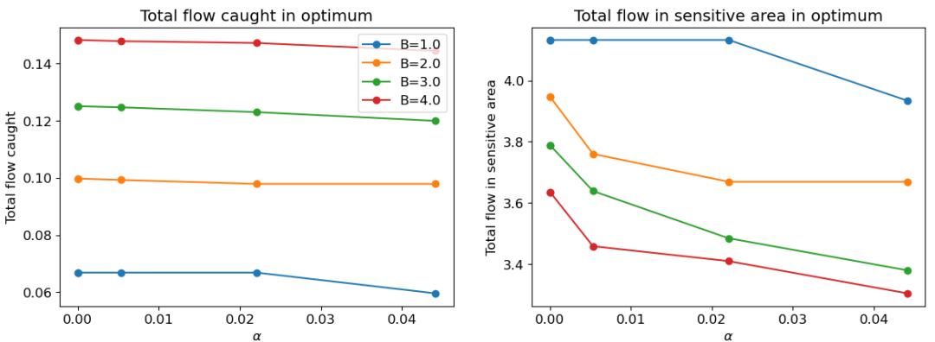  
In this example, different budgets are plotted and shown in the same figure. For all cases, 0.022 leads to a very small decrease in total flow caught (on the left) but a visible decrease in leftover flow on the right, which is why this value is chosen.

Choosing the desired value for the impact factor is unfortunately quite difficult because the total flow and total leftover flow as percentages are not very intuitive.

### Run the model one final time

After deciding the final values for $α$ and $w$, run the script “load_instance” again. The output is writtin to the file solution.txt which can be found in the folder “pulp_scripts”. It is not necessary to open or read this file since we will now go back to QGIS to see the solution on the map.

## Part 3: Show the solution on the map

1. Open the QGIS project again and open the Python file “show_solution” from the folder “pyqgis_scripts” in the QGIS Python window and run it. Two new layers should appear now, a solution layer and a nodes attributes layer.
   1. Load the style file “solution_style” from the “style_files” folder for the solution layer.
   2. Create graduated symbols with equal intervals for the column “plastic_flow” for the nodes attributes layer. This will show in graduated colors where the most plastic flow is expected when no catching systems are placed.
2. If you are unsatisfied with the result, it is wise to inspect the nodes_attributes layer to see if the variables are correctly defined for some of the solution locations that you are doubting. If you see some odd values, just change attribute values, save the layer and go back to Part 2, step 3 and 4.

## Further development of the model

Due to the limited time of a master’s thesis, several ideas were thought of but not implemented in the model yet. The most important ones are mentioned here. If any extra background is necessary, please read the [thesis](https://repository.tudelft.nl/record/uuid:28744e34-9bbc-40dc-9039-d52ed2f771e5) and the corresponding programming code. This part of the manual is not necessary for running the model, only if you wish to further develop it.

### Technical additions to the model

1. Nodes where the water direction changes but where there is no intersection

Right now the nodes in “waterways_simplified” are all nodes where no catching systems can be placed. This is because almost all of them are intersections. However, there are a few nodes where the direction of the water changes but there is no intersection (see example in screenshot below). In fact, it is possible to place a catching system there, but it is more difficult to calculate a good location for the second node (for the two possible orientations of the catching systems) on the map and due to limited time this was not implemented in the code. If the nodes are close together, this should not matter for the locations that the model will suggest as a solution because it will simply suggest the next closest node. But for larger areas where the nodes need to be further apart this might influence the solution. If this will be added to the model in the future, it is necessary to look into the code of the script “create_final_network” and to think about the geometry of the network (for the location of the nodes compared to the direction of the edges) and the way the nodes are connected to have edges in each necessary direction for the flow network. 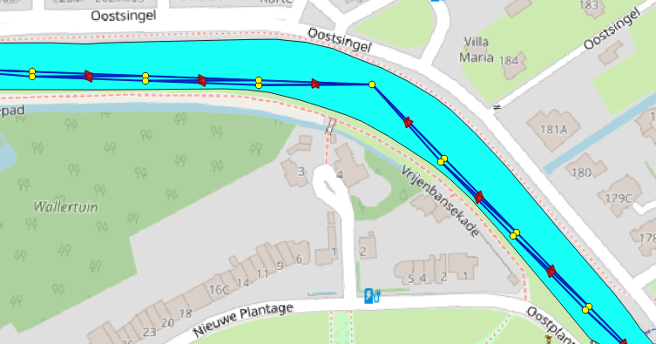



1. Adding areas where no catching system can be placed

Right now, the code is written such that the only locations where no catching systems can be placed are intersection nodes. It is possible that there are other areas where no catching systems can be placed (e.g. due to restrictions by the governments, ship routes etc). This can be added to the model by adding an extra step to part 1b of the tutorial where a multipolygon layer is created that shows the area where no catching systems are allowed. Then, the function “no_catching_system()” in the python script “load_instance” needs to be expanded such that all nodes that intersect the multipolygon layer are no longer considered as an option. If only one type of catching systems is not allowed in this location, the code of the function “MIP_inputs()” also needs to be adjusted in the lines where the sets $K_{i}$ are constructed.

1. Giving one or more catching system locations as input to the model that have been decided and letting the model find the next best locations

It is possible that the model is run for an area where one location (or more) has already been decided but the model should find the next best locations for extra catching systems. It is possible to add this by adding extra constraints to the MIP and setting $x_{ik}=1$ for location $i$ and type $k$ where the catching system has already been decided. The script “MDP_exact” needs to be adjusted to make this possible and it is necessary to look at the QGIS map and find the index of the node (in the attributes table) that is closest to the location that was already decided.

1. Sharp corners script

The script that calculates sharp corners has a bug for the start and end of a polygon drawing. Therefore, the script considers a few corners to be sharp while they are not. To fix this, some extra conditions need to be added to the script “sharp_corners” in the folder “pyqgis_scripts” with some clever geometry calculations. For now it also works to remove the corners that are not sharp manually as shown in part 1b step 6.

### More in depth research to develop the model

1. Sensitivity to location of nodes on the network.

Right now, the solution to the model is sensitive to the number of nodes in the network. This is explained in detail in the results and discussion of the [thesis](https://repository.tudelft.nl/record/uuid:28744e34-9bbc-40dc-9039-d52ed2f771e5) and seems to be largely caused by the way in which the width of the waterway influences the catching probability of a location. It would be interesting to investigate this further and to find a different way to calculate the catching probability such that it no longer depends on the exact position of the nodes but more on the average width of the waterway around the node.

1. Adjusting the transition probabilities when it is known that there is a flow direction different from the wind

Right now, the transition probabilities are fully based on wind. However, there are situations where tides or pumping stations may influence the direction in which plastics travel. It would be interesting to add the possibility to give extra transition probability to certain parts of the network when it is known that the water flow is different from the wind. It is important to consider that the outgoing transition probabilities of a node should still add to one, so it is necessary to think of a clever way to implement this in the model. This also requires a deep dive into the code in which transition probabilities are calculated.

1. Obtaining more data about the real life initial probability, transition probabilities and probability of getting stuck

Right now the probabilities in the model are fully based on estimations and experience. The reasoning behind this is mentioned in the [thesis](https://repository.tudelft.nl/record/uuid:28744e34-9bbc-40dc-9039-d52ed2f771e5). It would be interesting to specifically research by performing experiments what the “true” values of these probabilities are.

1. Testing the model on larger areas.

It would be interesting to test how the model works on larger areas such as provinces or even entire countries. The runtime of the model will likely increase a lot and it becomes more important to decide the location of the nodes. Probably, the transition probabilities in the model need to be calculated in a different way and this should be investigated.

1. Trade-off between active and passive systems.

Right now, the model prefers passive catching systems because their accuracy/price ratio is more favorable (accuracy 0.85 with costs 0.2) than for active catching systems (accuracy 0.98 with costs 1). The only situation in which the model might choose a passive system is when a high flow location has the constraint that no passive catching system is allowed there. It is interesting to test whether the model provides realistic results for these situations or if the model is not able to decide between the two types of systems.

## Contact details

If you have any questions about the model or the manual, feel free to reach out at any time. I am always interested in looking at the model again!

Anne-Fleur Dijkhorst  
[anne-fleur@dijkhorst.nl](mailto:anne-fleur@dijkhorst.nl)   
+31 6 25346023